Name:

Full working out must be shown to get full marks.
Attempt all questions
Total Time: Part A- 40 mins (40 Marks)

Part B- 15 mins (17 Marks)

Non Calculator Section
TIME ALLOWED: 40 min Total marks: 40

Question 1 [1, 2 = 3 marks]

The function is given by .

- Determine the coordinates of all axes intercepts of the graph of .

- can also be expressed in the form . Determine the value of the coefficient .

Question 2 [ 2, 2 = 4 marks]

a) Determine the equation of the circle shown below.

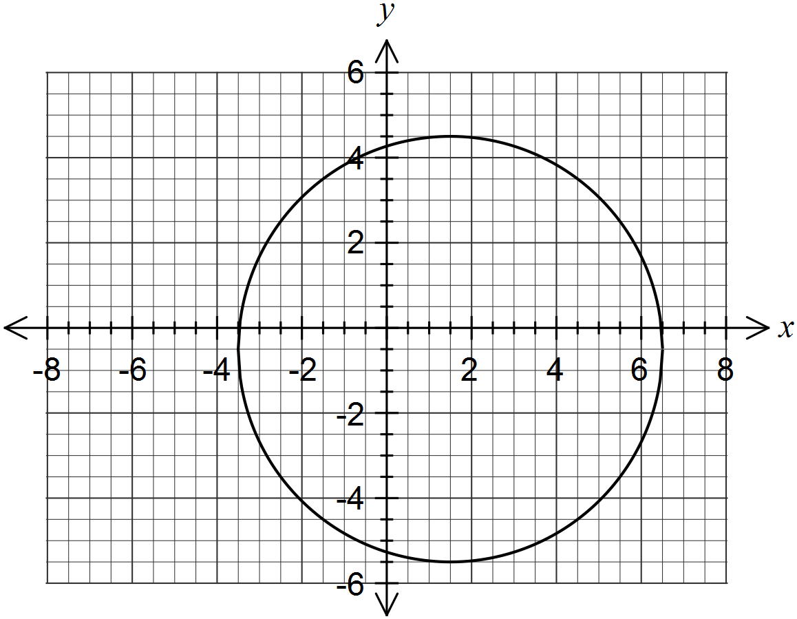

(b) Determine the radius of the circle with equation .

Question 3 [1, 2, 2 = 5 marks]

Given that $x^{3}-8x^{2}+19x-12=\left(x-3\right)\left(x^{2}+bx+c\right):$

- Determine the value of c by inspection.

- With your answer from part (a) in place of c determine b.

- Factorise $x^{3}-8x^{2}+19x-12$

Question 4 [1, 1, 1- 3 marks]
Give the amplitude and period for each of the following:
Function | Amplitude | Period
a)
b)
c)

Question 5 [2, 2 - 4 marks]
 | Give the equation of each of the following graphs:
a) | 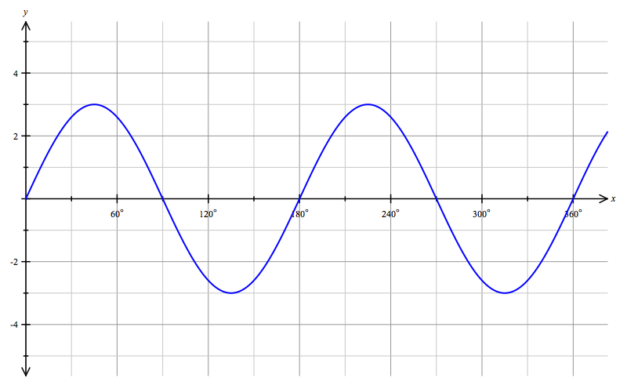  EQUATION :
b) | 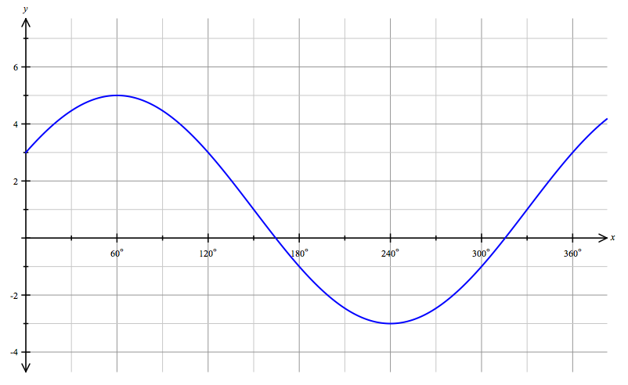  EQUATION:
Question 6 [2, 4- 6 marks]
 | Solve for
a) |  | b

Question 7 [2, 1- 3 marks]
Find the exact value of:
- $\tan{\frac{4π}{3}}$ = b) $\sin^{2}\left(\frac{π}{41}\right)+\cos^{2}\left(\frac{π}{41}\right)$=

Question 8 [ 3, 3 - 6 Marks]

Solve for $θ$ within the given domain.

a) $\left(cosθ\right)\left(2sinθ-1\right)=0$ where $0≤θ≤2π$

b) $\sqrt{2}\sin{θ}=-1$ where $0≤x≤360°$.

Question 9 [3, 3- 6 marks]
Use an appropriate trigonometric identity to find the exact value of:
(a) sin 75°

(b) $\tan{(})$

End of Part A

